## VISVESVARAYA TECHNOLOGICAL UNIVERSITY

Jnana Sangama, Belagavi - 590018, Karnataka, India



#### A MINI PROJECT REPORT ON

**“**EXPENSE TRACKER**”**

#### A Mini Project Work Report Submitted in partial fulfillment of the requirement for the degree of

**BACHELOR OF ENGINEERING**

**In**

**COMPUTER SCIENCE & ENGINEERING**

**Submitted by**

##### MOHAMMED TOUSEEF 1RG17CS031

**TANZIL PASHA 1RG17CS059**

**Under the Guidance of Mrs. PRAGATHI M**

Asst. Prof. Dept. of CSE RGIT, Bengaluru-32



Department of Computer Science & Engineering

**RAJIV GANDHI INSTITUTE OF TECHNOLOGY**

Cholanagar, R.T. Nagar Post, Bengaluru-560032

**2020-2021**

**RAJIV GANDHI INSTITUTE OF TECHNOLOGY**

**(Affiliated To Visvesvaraya Technological University) Cholanagar, R.T.Nagar Post, Bangalore-560032**



**Department of Computer Science Engineering CERTIFICATE**

Certified that the mini project work entitled **“****EXPENSE TRACKER”** carried out by **Mr. MOHAMMED TOUSEEF (1RG17CS031)** and **Mr. TANZIL PASHA (1RG17CS059),** bonafide students of **RAJIV GANDHI INSTITUTE OF TECHNOLOGY** in partial fulfillment for the award of **Bachelor of Engineering** in **Computer Science Engineering** of the **Visvesvaraya Technological University, Belgaum,** during the year **2020- 2021**. It is certified that all corrections/suggestions indicated for Internal Assessment have been incorporated in the Report deposited in the departmental library. The project report has been approved as it satisfies the academic requirements in respect of Project work prescribed for the said Degree.

|  |  |
| --- | --- |
| Signature of the Guide | Signature of the HOD |
| **Mrs. PRAGATHI M**  Asst. Professor | **Mrs. Arudra.A**  Professor & HOD |
| Dept. of CSE, | Dept. of CSE, |
| RGIT, Bengaluru | RGIT, Bengaluru |
| **External Viva** | |
| Name of the examiners | Signature with date |

**1.**

**2.**

**VISVESVARAYA TECHNOLOGICAL UNIVERSITY**

**JNANA SANGAMA, BELAGAVI-590018**

**RAJIV GANDHI INSTITUTE OF TECHNOLOGY**

DEPARTMENT OF COMPUTER SCIENCE & ENGINEERING



**DECLARATION**

We hereby declare that the mini project work entitled “EXPENSE TRACKER” submitted to the **Visvesvaraya Technological University, Belagavi** during the academic year **2020-2021**, is record of an original work done by us under the guidance of **Mrs. PRAGATHI M, Assistant Professor, Department of Computer Science and Engineering, Rajiv Gandhi Institute of Technology, Bengaluru** and this project work is submitted in the partial fulfillment of requirements for the award of the degree of **Bachelor of Engineering in Computer Science & Engineering**. The results embodied in this project have not been submitted to any other University or Institute for award of any degree or diploma.

#### MOHAMMED TOUSEEF 1RG17CS031

**TANZIL PASHA 1RG17CS059**

.

## ACKNOWLEDGEMENT`

We take this opportunity to express our sincere gratitude and respect to the **Rajiv Gandhi Institute of Technology, Bengaluru** for providing us an opportunity to carry out our project work.

We express our sincere regards and thanks to **Dr.Nagaraj.A.M, Principal, RGIT, Bangalore** and **Mrs.Arudra.A, Professor and Head, Department of Computer Science & Engineering, RGIT, Bengaluru,** for her encouragement and support throughout the Project.

With profound sense of gratitude, we acknowledge the guidance and support extended by **Mrs. PRAGATHI M, Asst. Prof, Department of Computer Science & Engineering, RGIT, Bengaluru.** Her incessant encouragement and valuable technical support have been of immense help in realizing this project. Her guidance gave us the environment to enhance our knowledge, skills and to reach the pinnacle with sheer determination, dedication and hard work.

We also extend our thanks to the entire faculty of the Department of CSE, RGIT, Bengaluru, who have encouraged us throughout the course of Bachelor Degree.

#### Name of Student

**MOHAMMED TOUSEEF (1RG16CS031)**

**TANZIL PASHA (1RG17CS059)**

**I**

## ABSTRACT

In today’s busy and expensive life we are in a great rush to make money. But at the end of the month we broke off. As we are unknowingly spending money on little and unwanted things. So, we have come over with the idea to track our earnings. Daily Expense Tracker (DET) aims to help everyone who are planning to know their expenses and save from it. DET is an android app which users can execute in their mobile phones and update their daily expenses so that they are well known to their expenses. Here user can define their own categories for expense type like food, clothing, rent and bills where they have to enter the money that has been spent and also can add some information in additional information to specify the expense. User can also define expense categories.

**II**

## TABLE OF CONTENTS

|  |  |  |
| --- | --- | --- |
| **Acknowledgement Abstract** |  | **i ii** |
| **CHAPTERS** | **TITLE** | **PAGE** |

|  |  |  |
| --- | --- | --- |
| **1** | **Introduction** | **1** |
|  | 1.1 Project Overview | 2 |
|  | 1.2 Project Description | 2 |
|  | 1.3 Scope of project | 3 |
|  | 1.4 Aim of project | 4 |
| **2** | **Requirement specification** | **5** |
|  | **2.1 Details of Software and languages** | 6 |
|  | 2.1.1 Introduction to MYSQL | 6 |
|  | 2.1.2 Introduction to XAMPP | 6 |
|  | 2.1.3 Introduction to PHP | 7 |
|  | **2.2 System Requirements** | 7 |
|  | 2.2.1 User Requirements | 7 |
|  | * + 1. Software Requirements     2. Hardware Requirements | 7  7 |
| **3** | **System Implementation** | **8** |

|  |  |  |
| --- | --- | --- |
| **4** | **Screenshots** | **17** |
| **5** | **Conclusion** | **23** |
|  | **Bibliography** | **24** |

**III**

|  |  |  |
| --- | --- | --- |
|  | **LIST OF FIGURES** |  |
| **FIGURE NO.** | **FIGURE NAME** | **PAGE NO.** |
| 4.1 | Login Page | 18 |
| 4,2 | Dashboard | 18 |
| 4.3 | Inventory Page | 19 |
| 4.4 | Add new item Page | 19 |
| 4.5 | Bills/Orders Page | 20 |
| 4.6 | Billing Page | 20 |
| 4.7 | Site setting Page | 21 |
| 4.8 | Profile setting Page | 21 |
| 4.9 | Account setting Page | 22 |

**IV**

# INTRODUCTION

### CHAPTER 1

**INTRODUCTION**

#### Project Overview

#### Expense Tracker (ET) aims to help everyone who are planning to know their expenses and save from it. ET is a web page where users can update their daily expenses so that they are well known to their expenses. Here user can define their own categories for expense type like food, clothing, rent and bills where they have to enter the money that has been spent and also can add some information in additional information to specify the expense. User can also define expense categories.

#### Project Description

The Expense Tracker is a complete dispensing workflow managing system that is designed to improve accuracy, enhance safety and efficiency in managing their salary. But at the end of the month we broke off. As we are unknowingly spending money on little and unwanted things. So, we have come over with the idea to track our earnings. It aims to help everyone who are planning to know their expenses and save from it. Expense Tracker is a simple webpage which users can update their daily expenses so that they are well known to their expenses. Here user can define their own categories for expense type like travelling, clothing, rent and bills where they have to enter the money that has been spent and also can add some information in additional information to specify the expense. User can also define expense categories. User will be able to see percentage of expense. Although this webpage is focused on new job holders, interns and teenagers, everyone who wants to track their expense can use this webpage.

Page|2

EXPENSE TRACKER INTRODUCTION

#### Scope of the project

This webpage can take a good market as it is usable by anyone who are willing to manage their expenses and aiming to save for the future investments and many more. There is not any range criteria or any kind of profession or gender are focused, it will used hugely. In the future, The Income and Expense Tracker webpage can be further enhanced to include features like this webpage can be extended to include scanning of barcode on the price tag which decreases the effort of entering the data in the input fields. This system can keep track of daily expenses and budgeting and can save money for pre-defined expenses which will help planning on your future investments

Dept of CSE 2020 -2021 Page|3

EXPENSE TRACKER INTRODUCTION

#### Aim of the Project

The main aim of this project is to minimize the paperwork of the people as minimum as possible by computerizing all the details regarding expenses , whether it is small or big and also to eliminate the redundant data and store the information of the daily expense safely for the future purpose.

Provides mass storage of relevant data. Make access to the data easy for the user. Provide prompt response to user requests for data. Making modifications to the database available immediately. Allow for multiple users to be active at one time. Having a good statistics part to know how much profit gained daily, monthly or even the specific date that the manager may need to get report about it. Benefits of this project in the current scenario make it economically feasible. The purpose of the economic feasibility assessment is to determine the positive economic benefits to the organization that the proposed system will provide. It includes quantification and identification of all the benefits expected. This assessment typically involves a cost/benefits analysis.

Dept. Of CSE, RGIT 2020-2021 Page|4

# REQUIREMENT SPECIFICATION

### CHAPTER 2

**REQUIREMENT SPECIFICATION**

### User Requirements

Easy to understand and should be simple.

Accessible with few clicks

### Software Requirements

Any OS

Editor: Visual Studio Code or Sublime text.

Languages: JavaScript & HTML.

### Hardware Requirements

Processor: Pentium or Higher. (Preferred x64 bit – Intel i3 processor 1.6GHz)

Ram: 4GB

Hard Disk: 500GB (At least 80GB)

Display: Intel HD graphics (128MB)

Keyboard, Mouse

Page | 6

SYSTEM IMPLEMENTATION

#### CHAPTER 3

**SYSTEM IMPLEMENTATION**

System implementation uses the structure created during architectural design and the results of system analysis to construct system elements that meet the stakeholder requirements and system requirements developments development in the early life cycle phases. These system elements are then integrated to form intermediate aggregates and finally the complete system of interest (SOI).

Implementation is the process that actually yields the lowest-level system elements in the system hierarchy (system break down structure). System elements are made, bought or reused. Production involves the hardware fabrication processes of forming, removing, joining and finishing. The software realization process of coding and testing or operational procedures development processes for operator roles. If implementation involves a production process a manufacturing system which uses the established technical and management processes may be required.

The purpose of implementation process is to design and create (or fabricate) a system elements conforming to that elements design properties and/or requirements. The element is constructed employing appropriate technologies and industry practices. The process bridges the system definition processes and the integration process.

#### Connection with Database

In order to establish the connection with the database following code is used here, **“local host:3308”** is the host name where 3308 is the port number, **“ root”** is the user name and **“STORE”** is the name of the database created which stores all the tables and stored procedures.

Page | 9

EXPENSE TRACKER SYSTEM IMPLEMENTATION

SOURCE CODE:

* {

margin: 0;

padding: 0;

box-sizing: border-box;

}

.clearfix::after {

content: "";

display: table;

clear: both;

}

body {

color: #555;

font-family: Open Sans;

font-size: 16px;

position: relative;

height: 100vh;

font-weight: 400;

}

.right { float: right; }

.red { color: #FF5049 !important; }

.red-focus:focus { border: 1px solid #FF5049 !important; }

#### Main part

.top {

height: 40vh;

background-image: linear-gradient(rgba(0, 0, 0, 0.35), rgba(0, 0, 0, 0.35)), url(../../images/back.png);

background-size: cover;

background-position: center;

position: relative;

}

.budget {

position: absolute;

width: 350px;

top: 50%;

left: 50%;

transform: translate(-50%, -50%);

color: #fff;

}

.budget__title {

font-size: 18px;

text-align: center;

margin-bottom: 10px;

font-weight: 300;

}

.budget__value {

font-weight: 300;

font-size: 46px;

text-align: center;

margin-bottom: 25px;

letter-spacing: 2px;

}

.budget__income,

.budget__expenses {

padding: 12px;

text-transform: uppercase;

}

.budget__income {

margin-bottom: 10px;

background-color: #28B9B5;

}

.budget__expenses {

background-color: #FF5049;

}

.budget__income--text,

.budget__expenses--text {

float: left;

font-size: 13px;

color: #444;

margin-top: 2px;

}

.budget__income--value,

.budget__expenses--value {

letter-spacing: 1px;

float: left;

}

.budget__income--percentage,

.budget__expenses--percentage {

float: left;

width: 34px;

font-size: 11px;

padding: 3px 0;

margin-left: 10px;

}

.budget__expenses--percentage {

background-color: rgba(255, 255, 255, 0.2);

text-align: center;

border-radius: 3px;

}

Dept of CSE,RGIT 2020-2021 Page|10

EXPENSE TRACKER SYSTEM IMPLEMENTATION

#### Bottom Page

.add {

padding: 14px;

border-bottom: 1px solid #e7e7e7;

background-color: #f7f7f7;

}

.add__container {

margin: 0 auto;

text-align: center;

}

.add__type {

width: 55px;

border: 1px solid #e7e7e7;

height: 44px;

font-size: 18px;

color: inherit;

background-color: #fff;

margin-right: 10px;

font-weight: 300;

transition: border 0.3s;

.add__description,

.add__value {

border: 1px solid #e7e7e7;

background-color: #fff;

color: inherit;

font-family: inherit;

font-size: 14px;

padding: 12px 15px;

margin-right: 10px;

border-radius: 5px;

transition: border 0.3s;

}

.add__description { width: 400px;}

.add__value { width: 100px;}

.add__btn {

font-size: 35px;

background: none;

border: none;

color: #28B9B5;

cursor: pointer;

display: inline-block;

vertical-align: middle;

line-height: 1.1;

margin-left: 10px;

}

Dept of CSE 2020-2021 Page|11

EXPENSE TRACKER SYSTEM IMPLEMENTATION

.add__btn:active { transform: translateY(2px); }

.add__type:focus,

.add__description:focus,

.add__value:focus {

outline: none;

border: 1px solid #28B9B5;

}

.add__btn:focus { outline: none; }

/***** LISTS *****/

.container {

width: 1000px;

margin: 60px auto;

}

.income {

float: left;

width: 475px;

margin-right: 50px;

}

.expenses {

float: left;

width: 475px;

}

h2 {

text-transform: uppercase;

font-size: 18px;

font-weight: 400;

margin-bottom: 15px;

}

.icome__title { color: #28B9B5; }

.expenses__title { color: #FF5049; }

.item {

padding: 13px;

border-bottom: 1px solid #e7e7e7;

}

.item:first-child { border-top: 1px solid #e7e7e7; }

.item:nth-child(even) { background-color: #f7f7f7; }

.item__description {

float: left;

}

Dept of CSE,RGIT 2020-2021 Page|12

.item__value {

float: left;

transition: transform 0.3s;

}

.item__percentage {

float: left;

margin-left: 20px;

transition: transform 0.3s;

font-size: 11px;

background-color: #FFDAD9;

padding: 3px;

border-radius: 3px;

width: 32px;

text-align: center;

}

.income .item__value,

.income .item__delete--btn {

color: #28B9B5;

}

.expenses .item__value,

.expenses .item__percentage,

.expenses .item__delete--btn {

color: #FF5049;

}

.item__delete {

float: left;

}

.item__delete--btn {

font-size: 22px;

background: none;

border: none;

cursor: pointer;

display: inline-block;

vertical-align: middle;

line-height: 1;

display: none;

}

.item__delete--btn:focus { outline: none; }

.item__delete--btn:active { transform: translateY(2px); }

.item:hover .item__delete--btn { display: block; }

.item:hover .item__value { transform: translateX(-20px); }

.item:hover .item__percentage { transform: translateX(-20px); }

Dept of CSE,RGIT 2020-2021 Page|13

#### Index.Js

// BUDGET CONTROLLER

var budgetController = (function(){

var Expense = function(id,description,value){

this.id = id;

this.description = description;

this.value = value;

this.percentage = -1;

};

Expense.prototype.calcPercentage = function(totalIncome){

if(totalIncome > 0){

this.percentage = Math.round((this.value / totalIncome) * 100);

} else {

this.percentage = -1;

}

}; Expense.prototype.getPercentage = function(){

return this.percentage;

};

var Income = function(id,description,value){

this.id = id;

this.description = description;

this.value = value;

};

var calculateTotal = function(type){

var sum = 0;

data.allItems[type].forEach(function(el){

sum += el.value;

});

data.totals[type] = sum;

}; var data = {

allItems: {

exp: [],

inc: []

},

totals: {

exp: 0,

inc: 0

},

Dept of CSE,RGIT 2020-2021 Page|14

EXPENSE TRACKER SYSTEM IMPLEMENTATION

budget: 0,

percentage: -1

};

return {

addItem: function(type, des, val){

var newItem,

ID

// Create new ID

if(data.allItems[type].length>0){

ID = data.allItems[type][data.allItems[type].length-1].id+1;

} else {

ID = 0;

}

// Create new item basec on "inc" or "exp" type

if(type === "exp"){

newItem = new Expense(ID,des,val);

} else if(type === "inc") {

newItem = new Income(ID,des,val);

}

// Push it into our data structure

data.allItems[type].push(newItem);

// Return the new element

return newItem;

},

deleteItem: function(type,id){

var ids,

index;

ids = data.allItems[type].map(function(el){

return el.id;

});

index = ids.indexOf(id);

if(index !== -1){

data.allItems[type].splice(index, 1);

}

},

Dept of CSE,RGIT 2020-2021 Page|15

EXPENSE TRACKER SYSTEM IMPLEMENTATION

calculateBudget: function(){

// Calculate total income and expenses

calculateTotal('exp');

calculateTotal('inc');

// Calculate budget: income - expenses

data.budget = data.totals.inc - data.totals.exp;

// Calculate the percentage of income that we spent

if(data.totals.inc>0){

data.percentage = Math.round((data.totals.exp / data.totals.inc) * 100);

} else {

data.percentage = -1;

}

},

calculatePercentage: function(){

data.allItems.exp.forEach(function(el){

el.calcPercentage(data.totals.inc);

});

},

getPercentage: function(){

var allPerc = data.allItems.exp.map(function(el){

return el.getPercentage();

});

return allPerc;

},

getBudget: function(){

return {

budget: data.budget,

totalInc: data.totals.inc,

totalExp: data.totals.exp,

percentage: data.percentage

}

} testitem: function(){

console.log(data);

}

}

})();

Dept of CSE,RGIT 2020-2021 Page|16

// UI CONTROLLER

var UIController = (function(){

var DOMstrings = {

inputType: ".add__type",

inputDescription: ".add__description",

inputValue: ".add__value",

inputBtn: ".add__btn",

incomeContainer: ".income__list",

expensesContainer: ".expenses__list",

budgetLabel: ".budget__value",

incomeLabel: ".budget__income--value",

expensesLabel: ".budget__expenses--value",

percentageLabel: ".budget__expenses--percentage",

container: ".container",

expensesPercLabel: ".item__percentage",

dateLabel: ".budget__title--month"

};

var formatNumber = function(num,type){

var numSplit,

int,

dec,

sign;

num = Math.abs(num);

num = num.toFixed(2);

numSplit = num.split(".");

int = numSplit[0];

if(int.length>3){

int = int.substr(0,int.length - 3)+"," + int.substr(int.length - 3,int.length);

}

dec = numSplit[1];

return (type === "exp" ? sign = "-" : sign = "+") + " " + int + "." + dec;

};

var nodeListForEach = function(list,callback){

for(var i=0; i<list.length; i++){

callback(list[i],i);

}

};

return {

getInput: function(){

return {

type: document.querySelector(DOMstrings.inputType).value,

description: document.querySelector(DOMstrings.inputDescription).value,

value: parseFloat(document.querySelector(DOMstrings.inputValue).value)

};

},

addListItem: function(obj,type){

var html,

newHtml,

element;

// Create HTML string with placeholder text

if(type === "inc"){

element = DOMstrings.incomeContainer;

html = '<div class="item clearfix" id="inc-%id%"><div class="item__description">%description%</div><div class="right clearfix"><div class="item__value">%value%</div><div class="item__delete"><button class="item__delete--btn"><i class="ion-ios-close-outline"></i></button></div></div></div>';

} else if(type === "exp"){

element = DOMstrings.expensesContainer;

html = '<div class="item clearfix" id="exp-%id%"><div class="item__description">%description%</div><div class="right clearfix"><div class="item__value">%value%</div><div class="item__percentage">21%</div><div class="item__delete"><button class="item__delete--btn"><i class="ion-ios-close-outline"></i></button></div></div></div>'

}

// Replace the placegolder text with some actual data

newHtml = html.replace("%id%",obj.id);

newHtml = newHtml.replace("%description%",obj.description);

newHtml = newHtml.replace("%value%", formatNumber(obj.value,type));

// Insert the HTML into the DOM

document.querySelector(element).insertAdjacentHTML("beforeend",newHtml);

},

deleteListItem: function(selectorID){

var el;

el = document.getElementById(selectorID);

el.parentNode.removeChild(el);

},

clearFields: function(){

var fields,

fieldsArr;

fields = document.querySelectorAll(DOMstrings.inputDescription+', '+DOMstrings.inputValue);

fieldsArr = Array.prototype.slice.call(fields);

fieldsArr.forEach(function(el,i,arr){

el.value = "";

});

fieldsArr[0].focus();

},

displayBudget: function(obj){

var type;

obj.budget > 0 ? type = "inc" : type = "exp";

document.querySelector(DOMstrings.budgetLabel).textContent = formatNumber(obj.budget,type);

document.querySelector(DOMstrings.incomeLabel).textContent = formatNumber(obj.totalInc,"inc");

document.querySelector(DOMstrings.expensesLabel).textContent = formatNumber(obj.totalExp,"exp");

if(obj.percentage>0){

document.querySelector(DOMstrings.percentageLabel).textContent = obj.percentage+"%";

} else {

document.querySelector(DOMstrings.percentageLabel).textContent = "---";

}

},

displayPercentages: function(percentages) {

var fields = document.querySelectorAll(DOMstrings.expensesPercLabel);

nodeListForEach(fields, function(el,i){

if(percentages[i]>0){

el.textContent = percentages[i] + "%";

} else {

el.textContent = "---";

}

});

},

displayMonth: function() {

var now,

month,

months,

year;

now = new Date();

months = ["January","February","March","April","May","June","July","August","September","October","November","December"];

month = now.getMonth();

year = now.getFullYear();

document.querySelector(DOMstrings.dateLabel).textContent = months[month] + " " + year;

},

changedType: function(){

var fields = document.querySelectorAll(

DOMstrings.inputType + "," +

DOMstrings.inputDescription + ',' +

DOMstrings.inputValue

);

nodeListForEach(fields, function(el){

el.classList.toggle("red-focus");

});

document.querySelector(DOMstrings.inputBtn).classList.toggle("red");

},

getDOMstrings: function(){

return DOMstrings;

}

};

})();

//GLOBAL APP CONTROLLER

var controller = (function(budgetCtrl,UICtrl){

var setupEventListeners = function(){

var DOM = UICtrl.getDOMstrings();

document.querySelector(DOM.inputBtn).addEventListener("click",ctrlAddItem);

document.addEventListener("keypress",function(event){

if(event.keyCode === 13 || event.which === 13){

ctrlAddItem();

}

});

document.querySelector(DOM.container).addEventListener("click", ctrlDeleteItem);

document.querySelector(DOM.inputType).addEventListener("change",UICtrl.changedType);

};

var updateBudget = function(){

// 1. Calculate the budget

budgetController.calculateBudget();

// 2. Return the budget

var budget = budgetController.getBudget();

// 3. Display the budget on the UI

UICtrl.displayBudget(budget);

};

var updatePercentages = function(){

// 1. Calculate percentages

budgetCtrl.calculatePercentage();

// 2. Read percentages from the budget controller

var percentages = budgetCtrl.getPercentage();

// 3. Update the UI with the new percentages

UICtrl.displayPercentages(percentages);

};

var ctrlAddItem = function(){

var input,

newItem,

addItem;

// 1. Get the field input data

input = UICtrl.getInput();

if(input.description !== "" && !isNaN(input.value) && input.value>0){

// 2. Add the item to the budget controller

newItem = budgetCtrl.addItem(input.type,input.description,input.value);

// 3. Add the item to the UI

addItem = UICtrl.addListItem(newItem,input.type);

// 4. Clear the fields

UICtrl.clearFields();

// 5. Calculate and update budget

updateBudget();

// 6. Calculate and update percentages

updatePercentages();

}

};

var ctrlDeleteItem = function(event){

var itemID,

splitID,

type,

ID;

itemID = event.target.parentNode.parentNode.parentNode.parentNode.id;

if(itemID){

splitID = itemID.split("-");

type = splitID[0];

ID = parseInt(splitID[1]);

// 1. Delete the item from the data structure

budgetController.deleteItem(type, ID);

// 2. Delete the item from the UI

UICtrl.deleteListItem(itemID);

// 3. Update and show the new budget

updateBudget();

// 4. Calculate and update percentages

updatePercentages();

}

};

return {

init: function(){

console.log("Application has started");

UICtrl.displayMonth();

UICtrl.displayBudget({

budget: 0,

totalInc: 0,

totalExp: 0,

percentage: -1

});

setupEventListeners();

}

}

})(budgetController,UIController);

controller.init();

# SCREENSHOTS

#### CHAPTER 5

##### Login Page

* 1. **Dashboard**

**SCREENSHOTS**

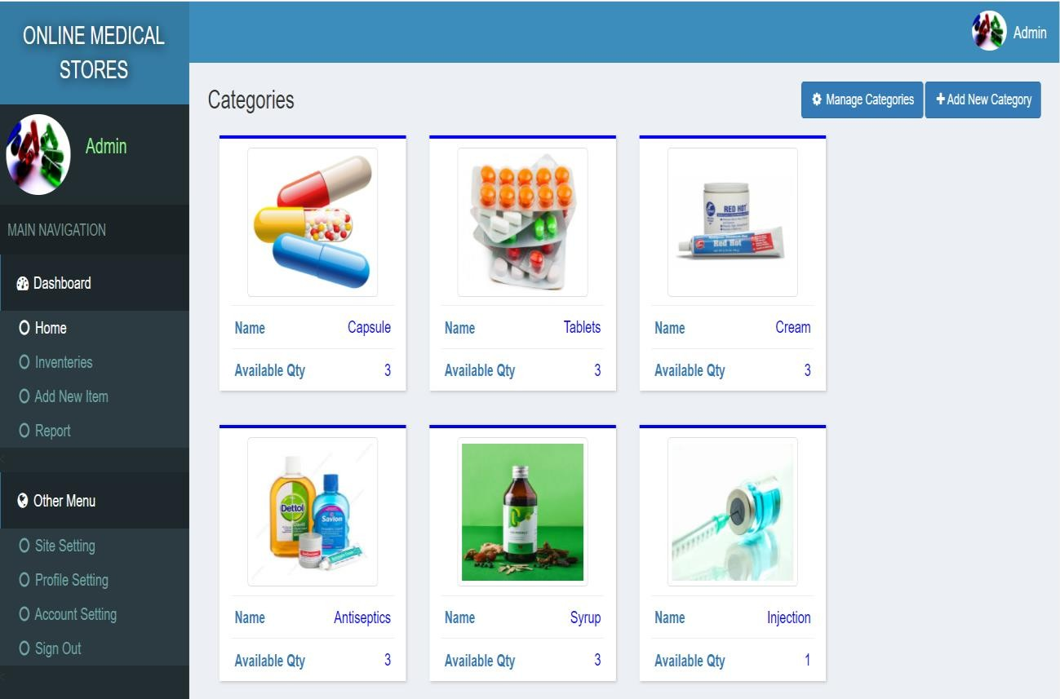

Page|18

* 1. **Inventory Page**

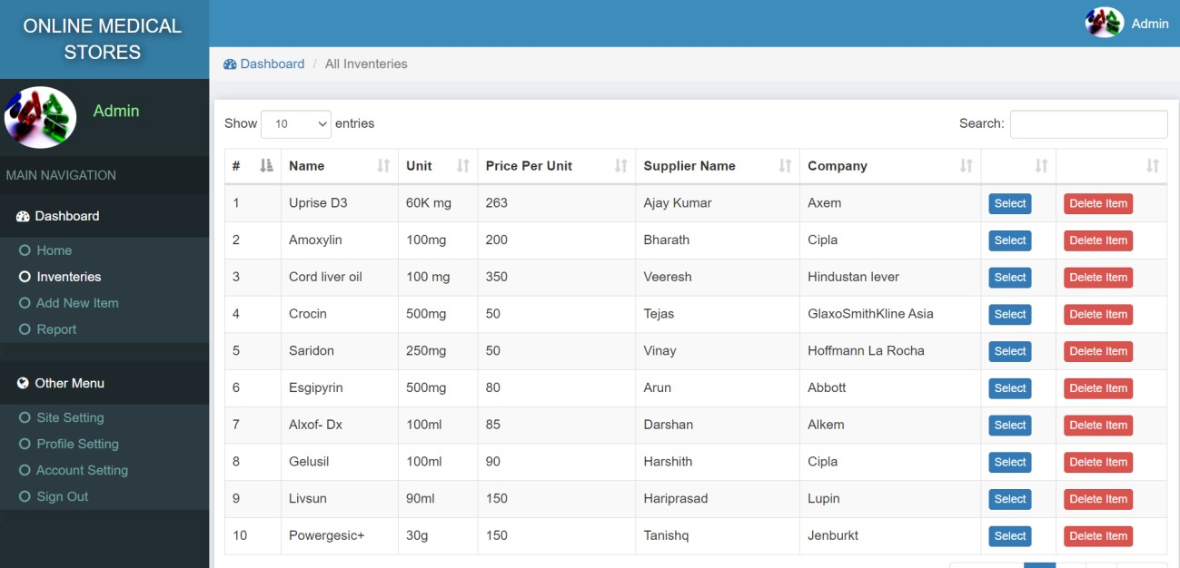

* 1. **Add New Item Page**

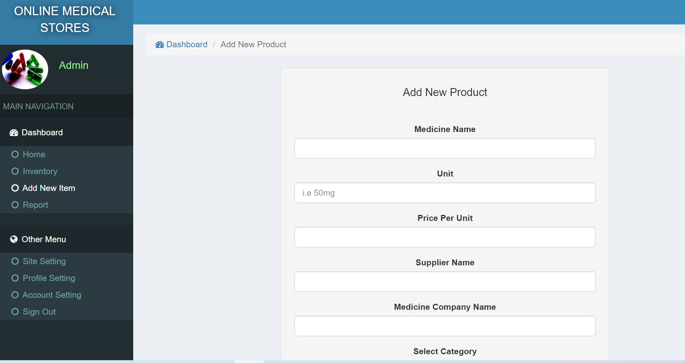

Dept of CSE,RGIT 2020-2021 Page|19

##### Bills/Orders Page

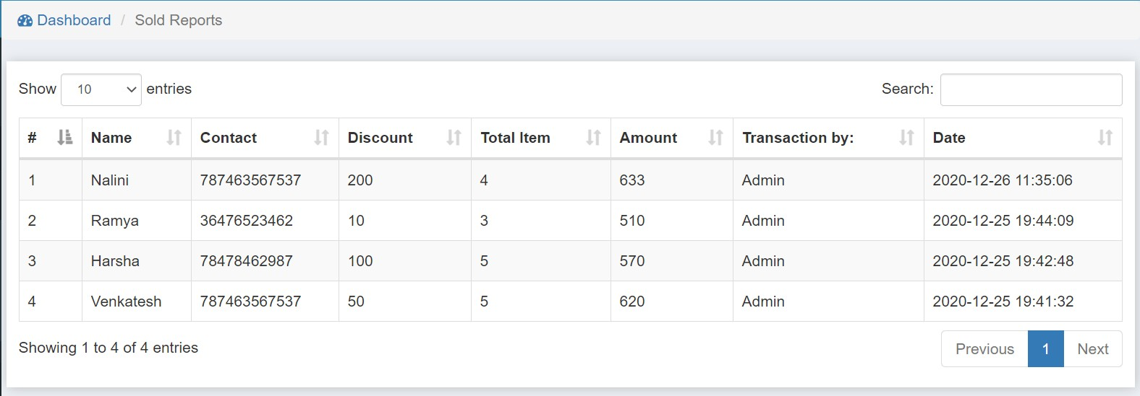

* 1. **Billing Page**

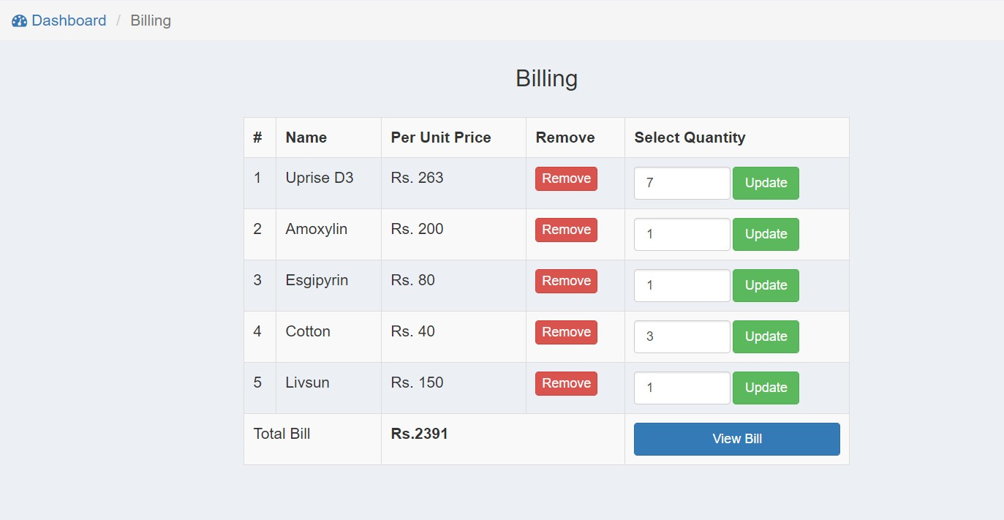

Dept of CSE,RGIT 2020-2021 Page|20

PHARMACY MANAGEMENT SYSTEM SCREENSHOTS

##### Site Settings Page

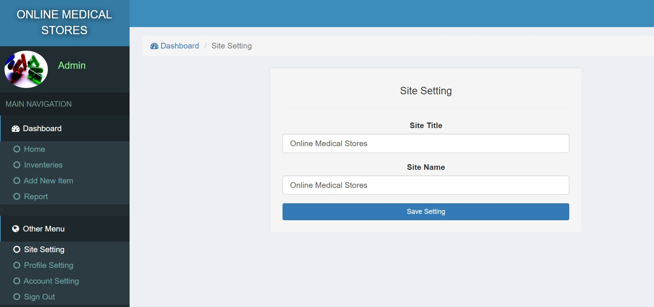

* 1. **Profile Settings Page**

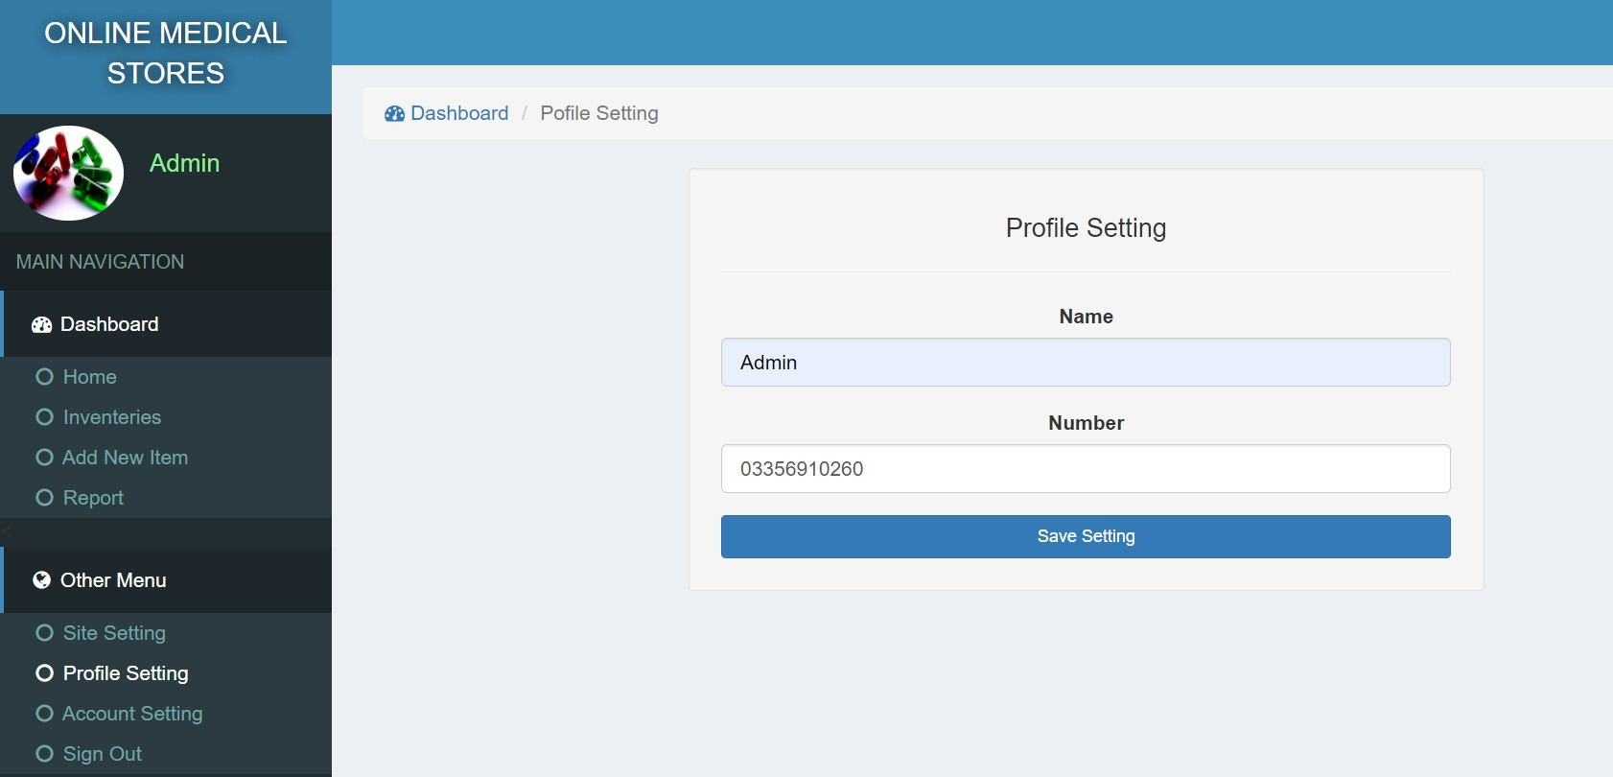

Dept of CSE,RGIT 2020-2021 Page|21

PHARMACY MANAGEMENT SYSTEM SCREENSHOTS

##### Account Settings Page

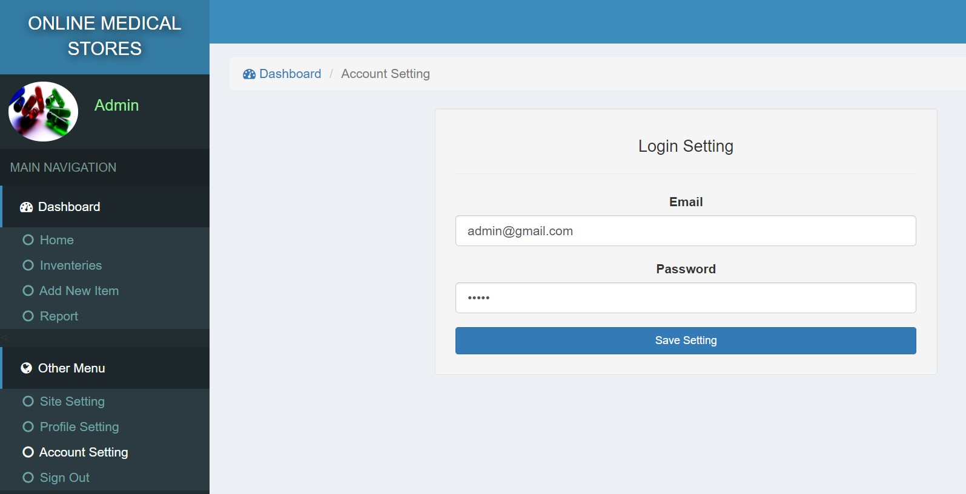

Dept of CSE,RGIT 2020-2021 Page|22

# CONCLUSION

#### CHAPTER 6

**CONCLUSION**

The project has been successfully completed but further it could have enhances. We have learnt a lot of new things while doing the project, which can prove very helpful in software field. By the user’s point of view, the PHP software is very easy to use. Also it is most widely used application in interaction. The purpose of developing this project is to exploit the resources provided by XAMPP and PHP.

**FUTURE ENHANCEMENTS**

There is still additional room for upgradation that would improve the quality of the software and make it more useful and user friendly. Some of the features that can be enhanced are:

* + - Email notifications and message notifications can be added upon placing the order.
    - Homepage of the application can be enhanced.
    - Other requirements as per user requirements can be included.
    - Reusability of the application is also possible.
    - Memberships can be provided to avail more discounts.

Page | 23

### BIBLIOGRAPHY

##### TEXTBOOKS

* CSS: The Definitive Guide
* HTML and CSS: Design and Build websites
* Coding with JavaScript
* The Joy of PHP Programming.

##### WEBSITES

* [www.w3schools.com](http://www.w3schools.com/)
* [www.medium.com](http://www.medium.com/)
* [www.codinginfinite.com](http://www.codinginfinite.com/)
* [www.coursera.org](http://www.coursera.org/)

Page | 24